]#Observation Record — TechSolutions Intranet

Participant ID: MD2

Observer: James

Date: 29/20/2026 Time:

1. Task Scenario
(Describe the realistic task the participant will complete.)

The user wants to book an appointment and get a confirmation message and have a reminder for it

2. Start and End Conditions
Start Condition:

End Condition:

3. Metrics

Completion Time
Start: ___10:20_____ End: ___10:28_____ Total: __8 minutes______

Outcome
☐ Success
☐ Partial Success
☐ Failed to Complete

Errors / Issues Observed
Step / Action | What Happened | Severity (L/M/H) | Evidence (e.g., quote, behaviour)
Wouldn’t let me book the appointment | Says something went wrong | h | “im going to die now”  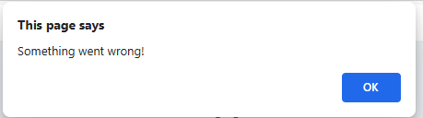
No option to book appointment date | I cant find where to book an appointment | h | “am I the magic man?”  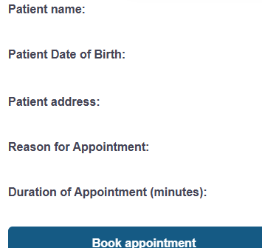
No contact information | No option for patients number to contact them | h | “Im not santa they don’t know my address”

4. System Behaviour Observed
(Error messages, slow loading, unclear labels, navigation problems)
Error message saying something went wrong when I tried to book the appointment
Navigation was simple and good
Labels were clear

5. Accessibility Notes
(Font size, clarity, ease of reading, motor/interaction difficulties, cognitive load)
Font size, clarity, ease was all good and simple, no difficulties only when I tired to book my appointment

6. Participant Quotes
(Write exact wording. Do not summarise.)
“I am not santa”
“am I the magic man?”
“im going to die now”
“I cant book an appointment”
“release me”

7. Initial Analysis — Proposed Improvements
(Observer notes only)
- Make the site work
- Let me book an appointment!!!!!!!!!!!!!!!!
- Let me select a date

8. Summary (to complete after observing)
Top 3 Issues:
- booking
- dates
- details

Suggested Fixes:
- actually make the site function

Linked Requirement / KPI:

